|  |  |
| --- | --- |
| **Name** | Muhammad Asad |
| **Reg. #** | 2019-EE-383 |

**EXPERIMENT #13**

**Frequency conversion or AC-AC conversion Objective:**

To simulate the AC-DC conversion and then DC-AC conversion to see the frequency conversion.

**Theory:**

A solid-state **AC-to-AC converter** converts an **AC** waveform to another **AC** waveform, where the output voltage and frequency can be set arbitrarily. These types of power electronic converters are used to convert the alternating current waveforms of specific magnitude and specific frequency into alternating current waveforms with different magnitude and different frequency, as the signal remains AC, hence this converter is termed as AC to AC converter. To operate a few devices and machines we require some specific voltage with specific frequency which can be obtained using AC to AC converters. By regulating [AC power](http://www.edgefx.in/dc-microgrid-wind-solar-power-integration/) using the AC to AC converter we can regulate the speed of induction motors. This type of converters are used for two grids working at different frequency and voltage, instead of creating new grid.

**Simulation:**

The simulation should be in this format as shown in figure 9.1

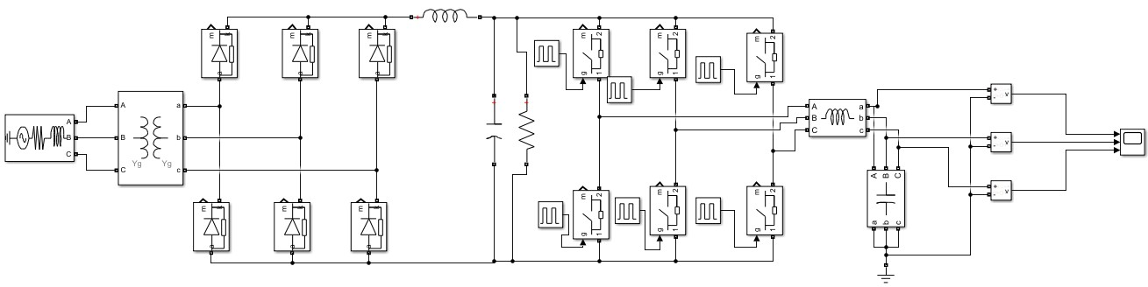

Figure 1: AC-AC conversion

As from figure 1 it is cleared that we can control the amplitude and frequency of output AC waveform through this conversion. This can be done by first converting AC to DC trough rectifier and then apply LC filter to get ripple free DC output. This DC output is fed into three phase DC to AC converter and to get three phase of AC output without ripples. LC filter has again applied at the end of model.

Use the relative value of frequency for calculation of filter parameters in above equation.

**Tasks**

* Design an AC to AC converter that converts frequency from 50 HZ to 130 HZ.
* Design a converter that converts voltage and frequency from 230V, 50HZ to 610V, 20HZ respectively.

**Task #01:**

Design an AC to AC converter that converts frequency from 50 Hz 230 volts to 130Hz 230 volts.

* **Circuit:**

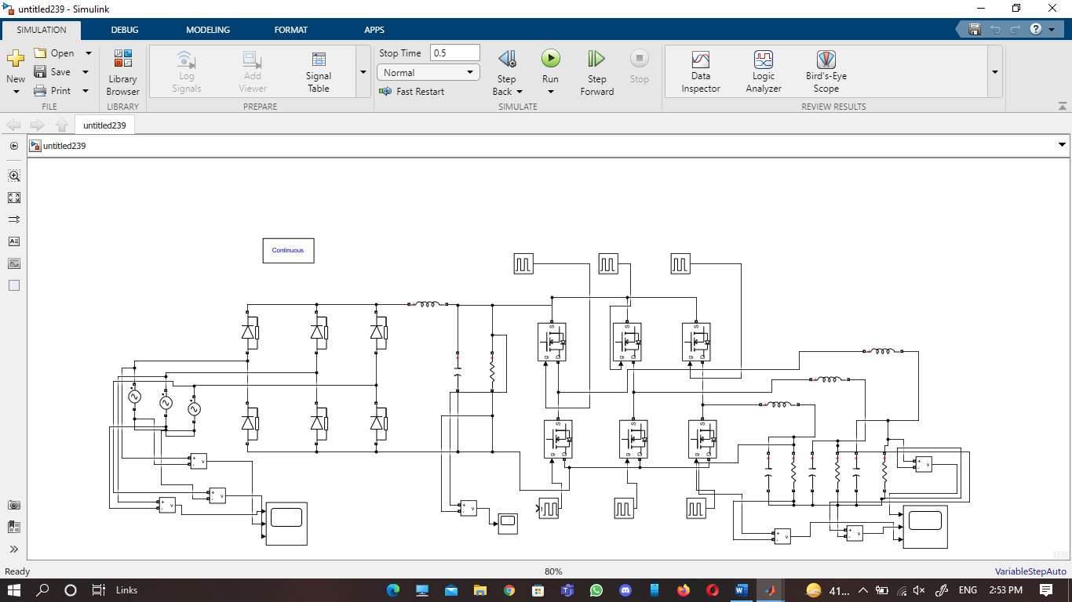

**Output voltage waveform:**

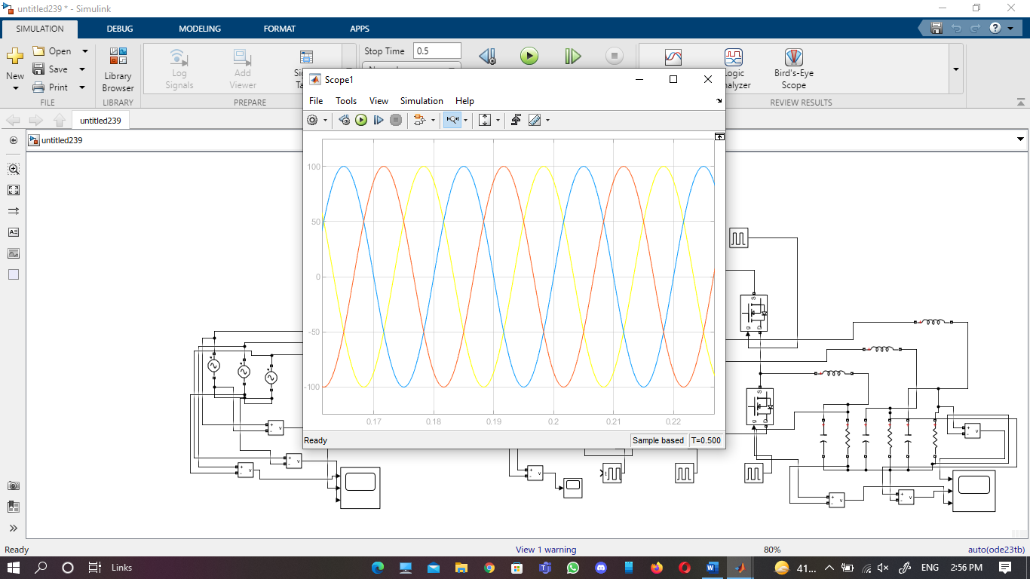

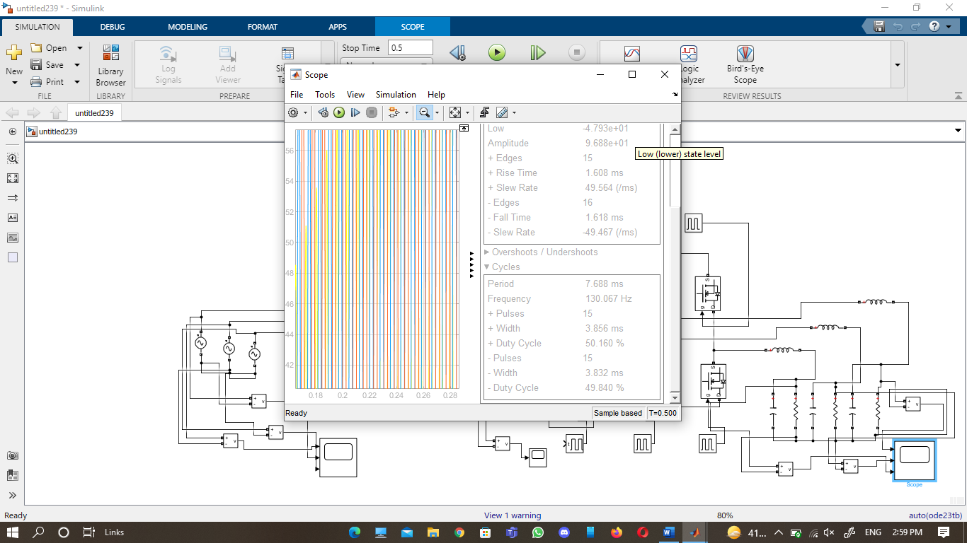

**Task #02:**

Design a converter that converts voltage and frequency from 230V, 50HZ to 610V, 20HZ respectively.